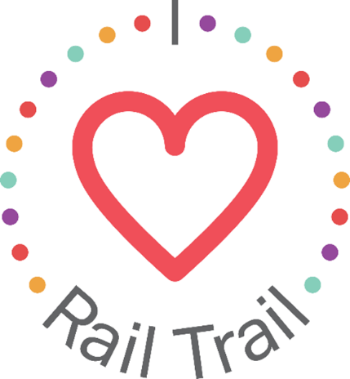
Contact:
Adam Rhew
Charlotte Center City Partners
704-891-4396
arhew@charlottecentercity.org

Celebrate Valentine’s Day on the Rail Trail, thanks to U.S. Bank

What: A pop up celebration of love, featuring free portraits and a limited number of free roses at the Confetti Hearts Mural in South End.
When: Saturday, Feb. 12, 12:00-1:00 p.m.
Where: The Design Center, 1920 Camden Rd., next to Twenty Degrees Chocolate

Roses are red, violets are blue, stop by the Rail Trail for free photos for your sweetie and you! South End residents and visitors are invited to stop at Evelyn Henson’s Instagram-famous Confetti Hearts Mural on Saturday, Feb. 12 at 12:00 p.m. for free portraits by Austin Caine Photography in honor of Valentine’s Day! The first 100 people can also pick up a rose to keep for themselves, or to give to their valentine (or galentine). Roses will be provided by Bookout Blooms. In addition to the portraits, attendees are welcome to register for a one-hour lovers-themed walking art tour, starting at 11:00 am at the nearby Krispy Kreme Donuts (2116 Hawkins Street). The art tour will end at the Confetti Hearts Mural. RSVP for the art walk using the following link: https://www.eventbrite.com/e/artwalks-artist-lovers-artwalk-tickets-262543192757
The free portraits are part of the I Heart Rail Trail initiative, a partnership between the Charlotte Rail Trail, Charlotte Center City Partners and U.S. Bank. The program features events large and small to activate the Rail Trail and enhance the experience of this 3.5-mile linear park. In addition to sponsoring the I Heart Rail Trail initiative, in 2019 U.S. Bank contributed $1 million toward the planned construction of a pedestrian bridge that will connect the South End and Uptown portions of the Rail Trail.
The partnership between U.S. Bank and the Charlotte Rail Trail is part of U.S. Bank’s Community Possible program. U.S. Bank's unified giving and engagement strategy Community Possible focuses on closing the gaps between people and possibility in the areas of Work, Home and Play. The bank believes the building blocks of all thriving communities where all things are possible include stable employment opportunities, a home to call your own, and a community connected through culture, arts, recreation, and play. Visit www.usbank.com/community for more information.

