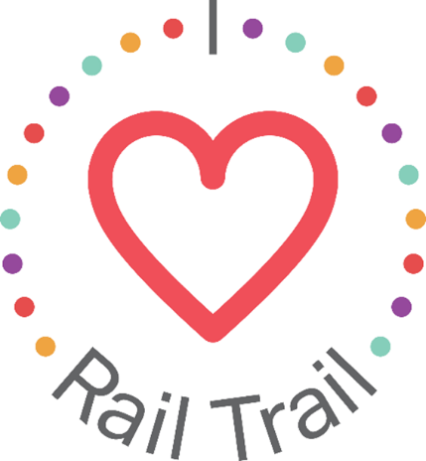
Contact:
Adam Rhew
Charlotte Center City Partners
704-891-4396
arhew@charlottecentercity.org

Celebrate Dog Days in South End with a S-wag Bag Giveaway, sponsored by U.S. Bank

What: S-wag bag giveaway, photo opportunity, and chalk art
When: Thursday, Aug. 26, 11:00 a.m.
Where: Pet Wants, 1700 Camden Rd., Suite 102

Who let the dogs out? Celebrate National Dog Day with an ulti-mutt giveaway at local pups’ favorite shop, Pet Wants, sponsored by U.S. Bank. Pet parents can visit the South End Pet Wants store to claim a free swag bag, including a U.S. Bank leash, Rail Trail stickers, waste bags, Pet Wants treats, food measuring cup, and more! Take photos with furry friends at the photo booth outside of the store, and tag @petwants on Instagram to receive 10% off a purchase. Look across the street to find a temporary art installation at the Rail Trail Chalkboard, created by Charlotte Chalk Art.
The s-wag bag giveaway is part of the I Heart Rail Trail initiative, a partnership between the Charlotte Rail Trail, Charlotte Center City Partners and U.S. Bank. The program will feature events large and small to activate the Rail Trail and enhance the experience of this 3.5-mile linear park. In addition to sponsoring the I Heart Rail Trail initiative, in 2019 U.S. Bank contributed $1 million toward the planned construction of a pedestrian bridge that will connect the South End and Uptown portions of the Rail Trail.
The partnership between U.S. Bank and the Charlotte Rail Trail is part of U.S. Bank’s Community Possible program. U.S. Bank's unified giving and engagement strategy Community Possible focuses on closing the gaps between people and possibility in the areas of Work, Home and Play. The bank believes the building blocks of all thriving communities where all things are possible include stable employment opportunities, a home to call your own, and a community connected through culture, arts, recreation, and play. Visit www.usbank.com/community for more information.

