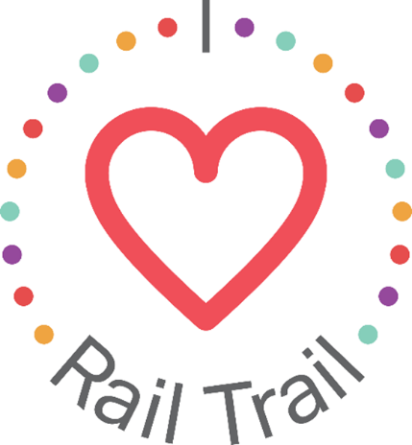
Contact:
Adam Rhew
Charlotte Center City Partners
704-891-4396
arhew@charlottecentercity.org

Celebrate Halloween at ImaginOn’s Fall Crawl, with U.S. Bank

What: Halloween celebration at ImaginOn
When: Wednesday, Oct. 27, 10:00 a.m. – 1:00 p.m.
Where: ImaginOn, 300 E. 7th St.
Celebrate spooky season just off the Rail Trail at ImaginOn’s Fall Crawl on Wednesday, October 27. Expect take-and-make crafts including a pumpkin patch, ghost lollipop, and spider hat, as well as Halloween music, a scavenger hunt, and a trick-or-treat station. Attendees can grab a specialty Halloween bag, courtesy of U.S. Bank, to collect goodies while at the event. ImaginOn opened in 2005 as a combination library and theatre space where stories come to life; there are two state-of-the-art theatres, a library for youth under the age of 11 and for teens, four multi-use classrooms, multimedia production studio, and an interactive exhibit space. Located on the Rail Trail and adjacent to 7th Street Station, ImaginOn is a kid’s paradise in the heart of Uptown Charlotte.
The trick-or-treat bag giveaway is part of the I Heart Rail Trail initiative, a partnership between the Charlotte Rail Trail, Charlotte Center City Partners and U.S. Bank. The program will feature events large and small to activate the Rail Trail and enhance the experience of this 3.5-mile linear park. In addition to sponsoring the I Heart Rail Trail initiative, in 2019 U.S. Bank contributed $1 million toward the planned construction of a pedestrian bridge that will connect the South End and Uptown portions of the Rail Trail.
The partnership between U.S. Bank and the Charlotte Rail Trail is part of U.S. Bank’s Community Possible program. U.S. Bank's unified giving and engagement strategy Community Possible focuses on closing the gaps between people and possibility in the areas of Work, Home and Play. The bank believes the building blocks of all thriving communities where all things are possible include stable employment opportunities, a home to call your own, and a community connected through culture, arts, recreation, and play. Visit www.usbank.com/community for more information.

