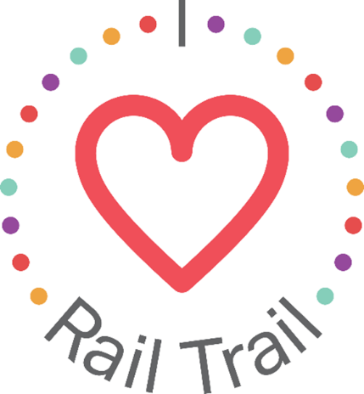
Contact:
Adam Rhew
Charlotte Center City Partners
704-891-4396
arhew@charlottecentercity.org

Donate a Book in South End for National Do Something Nice Day

Ready, set, read! U.S. Bank is celebrating National Do Something Nice Day by hosting a neighborhood book drive, encouraging residents to drop off their unwanted books at one of the five Little Free Libraries in South End. U.S. Bank will also be making a donation to the campaign so that South End always has something to read! The Little Free Libraries were created by Glen and Maria Nocik at ACSM and C3 Lab, and are located at the Charlotte Urban Design Center, 1100 South, MAA 1225, SILOS, and The Hub at South End.
The Charlotte Urban Design Center is located at 1507 Camden Road, 1100 South at 1100 South Blvd, MAA 1225 at 1225 South Church Street, SILOS at 131 Poindexter Drive, and The Hub at 2250 Hawkins Street. Each location has unique seating options for those who want to kick back and relax with a good book, and MAA 1225 and 1100 South both have fabulous views of the Charlotte Skyline. Learn more about and see photos of the Little Free Libraries at southendclt.org/live/little-free-libraries.
The South End Book Drive is part of the I Heart Rail Trail initiative, a partnership between the Charlotte Rail Trail, Charlotte Center City Partners and U.S. Bank. The program will feature events large and small to activate the Rail Trail and enhance the experience of this 3.5-mile linear park. In addition to sponsoring the I Heart Rail Trail initiative, in 2019 U.S. Bank contributed $1 million toward the planned construction of a pedestrian bridge that will connect the South End and Uptown portions of the Rail Trail.
The partnership between U.S. Bank and the Charlotte Rail Trail is part of U.S. Bank’s Community Possible program. U.S. Bank's unified giving and engagement strategy Community Possible focuses on closing the gaps between people and possibility in the areas of Work, Home and Play. The bank believes the building blocks of all thriving communities where all things are possible include stable employment opportunities, a home to call your own, and a community connected through culture, arts, recreation, and play. Visit www.usbank.com/community for more information.

