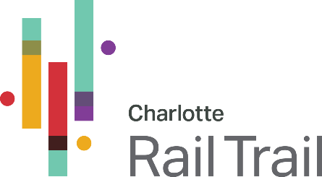

MEDIA CONTACT
Adam Rhew
Charlotte Center City Partners
704-891-4396
arhew@charlottecentercity.org
Moira Quinn
Charlotte Center City Partners
704-363-1298
mquinn@charlottecentercity.org
Media Advisory: Public-Private Partnership to Unveil Updated Renderings of Rail Trail Bridge Linking Uptown and South End
WHAT: Press conference and unveiling of bridge renderings
WHEN: Tuesday, Dec. 7, 11 a.m.
WHERE: Charlotte Urban Design Center, 1507 Camden Rd.
CHARLOTTE – (Dec. 2, 2021) – A public-private partnership among the City of Charlotte, Mecklenburg County, North Carolina Department of Transportation, U.S. Bank, Charlotte Center City Partners, and other private sector investors will provide an update to the media about the design of the forthcoming Rail Trail Bridge that will link Uptown and South End.
At a press event on Tuesday, Dec. 7 at 11 a.m., leaders including Charlotte City Council Member Larken Egleston and Mecklenburg Board of County Commissioners Chairman George Dunlap, along with executives from U.S. Bank, will unveil updated renderings of the bridge and provide a report on the project’s status. U.S. Bank has committed $1 million to the construction of this important piece of infrastructure, which fills a gap in the Rail Trail over I-277. This event is restricted to members of the media, who are invited to attend by registering with Adam Rhew: arhew@charlottecentercity.org.
The general public is invited to view the renderings and speak with City officials about the project at a community meeting on Tuesday, Dec. 7, from 5-7 p.m. at the Charlotte Urban Design Center, 1507 Camden Road. This meeting is open to all; preregistration is not required.
Both events will adhere to current public health orders regarding masks in public spaces.
-30-

