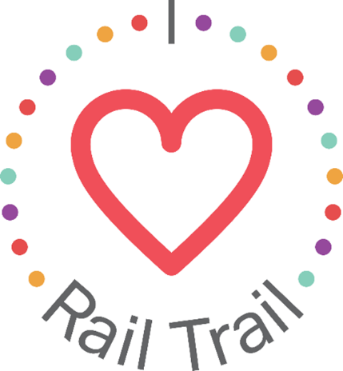
Contact:
Adam Rhew
Charlotte Center City Partners
704-891-4396
arhew@charlottecentercity.org

Squeeze the Day with Lemonade-Flavored Popsicles in South End, sponsored by U.S. Bank

What: Lemonade-flavored popsicles in celebration of back-to-school and National Lemonade Day
When: Saturday, Aug. 21, between 8:00 a.m. and 1:00 p.m.
Where: South End Market at Atherton Mill, 2140 South Blvd.

Anything is popsicle when you’re going back to school! Celebrate the start of a new school year, and National Lemonade Day, with U.S. Bank at the South End Market on Saturday, Aug. 21. We will give away 100 King of Pop popsicles at the Market’s Back to School Event. Popsicle flavors include lemonade, pink lemonade, and strawberry lemonade! The South End Market’s Back to School event will feature 25 local farmers, food artisans and crafters; a live children’s cooking demo by Chef Alyssa Wilen of Chef Alyssa’s Kitchen; live farm animals; face painting; hair feathering; and music by popular local artist MonaLisa. The Market is free to attend, and attendees should look for the free lemonade sign and King of Pop cart to grab their sweet treat. After all, when life gives you lemons, make lemonade!
The popsicle giveaway is part of the I Heart Rail Trail initiative, a partnership between the Charlotte Rail Trail, Charlotte Center City Partners and U.S. Bank. The program will feature events large and small to activate the Rail Trail and enhance the experience of this 3.5-mile linear park. In addition to sponsoring the I Heart Rail Trail initiative, in 2019 U.S. Bank contributed $1 million toward the planned construction of a pedestrian bridge that will connect the South End and Uptown portions of the Rail Trail.
The partnership between U.S. Bank and the Charlotte Rail Trail is part of U.S. Bank’s Community Possible program. U.S. Bank's unified giving and engagement strategy Community Possible focuses on closing the gaps between people and possibility in the areas of Work, Home and Play. The bank believes the building blocks of all thriving communities where all things are possible include stable employment opportunities, a home to call your own, and a community connected through culture, arts, recreation, and play. Visit www.usbank.com/community for more information.

