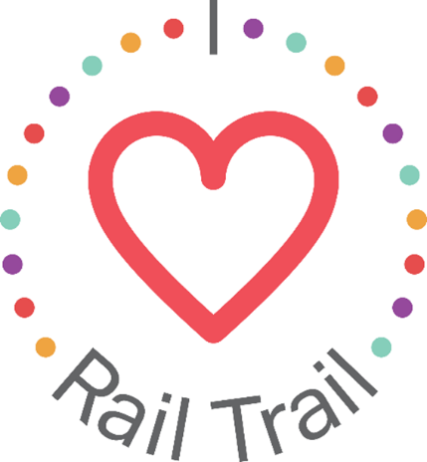
Contact:
Adam Rhew
Charlotte Center City Partners
704-891-4396
arhew@charlottecentercity.org

Join U.S. Bank and Volofit for a Free Workout to Commemorate Veteran’s Day

What: Free workout for veterans and their families to commemorate Veteran’s Day
When: Wednesday, Nov. 10, 6:30-7:30 p.m.
Where: Wilmore Centennial Park, corner of South Tryon St. and Kingston Ave.

Veterans and their families are invited to join U.S. Bank for a free workout on Wednesday, Nov. 10 in commemoration of Veteran’s Day. The workout will be led by Coach Shannon of Volofit, a functional fitness gym new to the district. Coach Shannon is a former Marine ready to bring the heat in the 50-minute high intensity interval training class, held at Wilmore Centennial Park on the corner of South Tryon Street and Kingston Avenue. Refresh after the class with a free juice from local favorite Green Brothers Juice Co. Attendees are encouraged to arrive 15 minutes early and to bring a mat. Street parking is available in the surrounding neighborhood. Water will be provided, and the class size is limited to 30 participants to ensure safety while working with a trainer. Volofit workouts focus equally on endurance, strength, power, and agility, so get ready to sweat in South End! Register for the class here: https://www.eventbrite.com/e/free-workout-in-commemoration-of-veterans-day-tickets-191758694417
The Veteran’s Day workout is part of the I Heart Rail Trail initiative, a partnership between the Charlotte Rail Trail, Charlotte Center City Partners and U.S. Bank. The program will feature events large and small to activate the Rail Trail and enhance the experience of this 3.5-mile linear park. In addition to sponsoring the I Heart Rail Trail initiative, in 2019 U.S. Bank contributed $1 million toward the planned construction of a pedestrian bridge that will connect the South End and Uptown portions of the Rail Trail.
The partnership between U.S. Bank and the Charlotte Rail Trail is part of U.S. Bank’s Community Possible program. U.S. Bank's unified giving and engagement strategy Community Possible focuses on closing the gaps between people and possibility in the areas of Work, Home and Play. The bank believes the building blocks of all thriving communities where all things are possible include stable employment opportunities, a home to call your own, and a community connected through culture, arts, recreation, and play. Visit www.usbank.com/community for more information.

