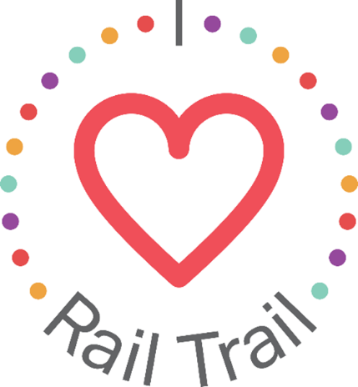
Contact:
Adam Rhew
Charlotte Center City Partners
704-891-4396
arhew@charlottecentercity.org

Mobile Bike Repair Station Coming to the Rail Trail, thanks to U.S. Bank

What: Mobile bike repair station on the Rail Trail for World Recreation Day
When: 4-7 pm on November 2, 2021
Where: Kingston Plaza, 115 East Kingston Ave, Charlotte, NC 28203

Smooth out your ride with a free bike repair from Queen City Bicycles on the Rail Trail for World Recreation Day. Riders can get minor shift and brake adjustments and their chains cleaned between 4-7 p.m. on Nov. 2 at Kingston Plaza, next to the Rail Trail chalkboard. Queen City Bicycles will also be offering in-shop discounts for those who come to the Rail Trail needing full tune-ups.
The mobile bike repair is part of the I Heart Rail Trail initiative, a partnership between the Charlotte Rail Trail, Charlotte Center City Partners and U.S. Bank. The program will feature events large and small to activate the Rail Trail and enhance the experience of this 3.5-mile linear park. In addition to sponsoring the I Heart Rail Trail initiative, in 2019 U.S. Bank contributed $1 million toward the planned construction of a pedestrian bridge that will connect the South End and Uptown portions of the Rail Trail.
The partnership between U.S. Bank and the Charlotte Rail Trail is part of U.S. Bank’s Community Possible program. U.S. Bank's unified giving and engagement strategy Community Possible focuses on closing the gaps between people and possibility in the areas of Work, Home and Play. The bank believes the building blocks of all thriving communities where all things are possible include stable employment opportunities, a home to call your own, and a community connected through culture, arts, recreation, and play. Visit www.usbank.com/community for more information.

