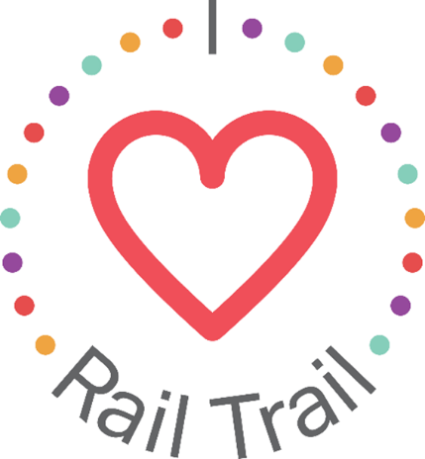
Contact:
Adam Rhew
Charlotte Center City Partners
704-891-4396
arhew@charlottecentercity.org

Stroll the Rail Trail with a Free Coffee on National Coffee Day, presented by U.S. Bank

What: Coffee Giveaway with Central Coffee Co. in celebration of National Coffee Day
When: Wednesday, Sept. 29 starting at 6:00 a.m.
Where: Central Coffee Co., 1700 Camden Road, Charlotte
Something is brewing in South End! National Coffee Day is on September 29, and U.S. Bank is giving away 150 free small, hot cups of coffee on the Rail Trail to celebrate. The first 150 people to stop by Central Coffee Co. on Camden Road can claim a free small, hot cup of coffee to help kick start the day. Central Coffee Co. has been a neighborhood favorite since 2016, serving Joe Van Gogh coffee roasted in Hillsborough, N.C.
The coffee giveaway is part of the I Heart Rail Trail initiative, a partnership between the Charlotte Rail Trail, Charlotte Center City Partners and U.S. Bank. The program will feature events large and small to activate the Rail Trail and enhance the experience of this 3.5-mile linear park. In addition to sponsoring the I Heart Rail Trail initiative, in 2019 U.S. Bank contributed $1 million toward the planned construction of a pedestrian bridge that will connect the South End and Uptown portions of the Rail Trail.
The partnership between U.S. Bank and the Charlotte Rail Trail is part of U.S. Bank’s Community Possible program. U.S. Bank's unified giving and engagement strategy Community Possible focuses on closing the gaps between people and possibility in the areas of Work, Home and Play. The bank believes the building blocks of all thriving communities where all things are possible include stable employment opportunities, a home to call your own, and a community connected through culture, arts, recreation, and play. Visit www.usbank.com/community for more information.

